Mark your calendar for the
2024 St. Joseph’s Day Dance
Brought to you by The Czech Heritage Foundation

Music by Becky & The Ivanhoe Dutchmen
Sunday, March 24, 2024
1 pm – 5 pm

DanceMor
77 2nd St SE, Swisher, IA 52338
Tickets are $10 per person and available at the door
21 and under FREE

50/50 Raffle | Bake Sale

Tell all your friends
Or better yet, take this flier to them!!

All profits go to support the many educational projects and programs of
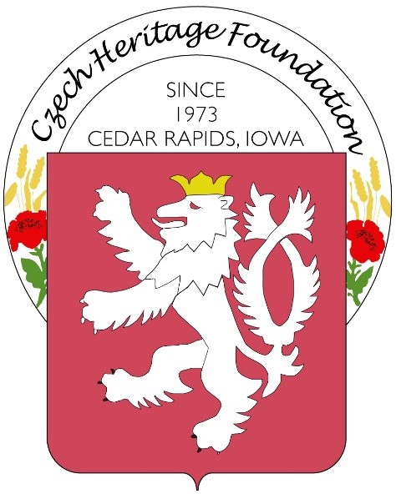
The Czech Heritage Foundation of Iowa

